**CISCO.** Cisco Networking Academy· Mind Wide Open

# Lab - Using a Multimeter and a Power Supply Tester

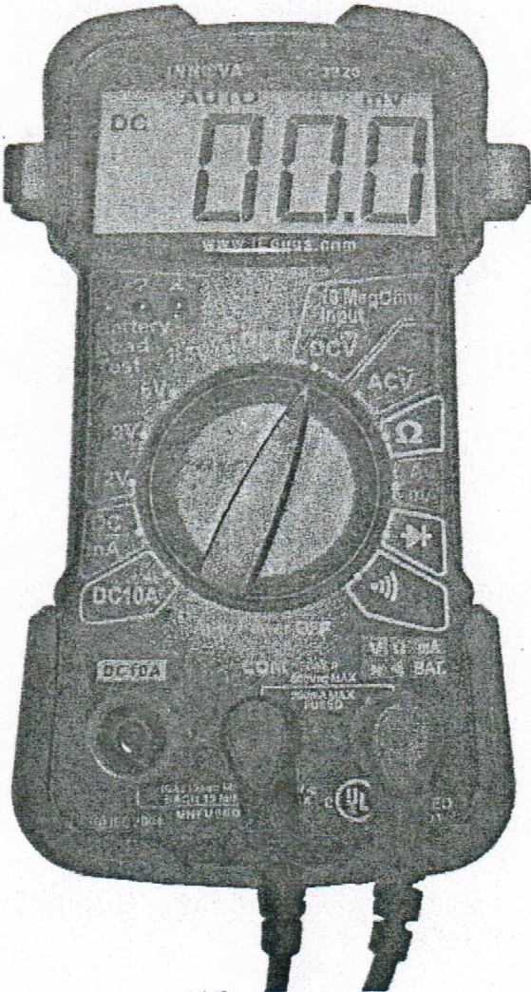

## Introduction

In this lab, you will learn how to use and handle a multimeter and a power supply tester.

## Recommended Equipment

* A digital multimeter
* The multimeter manual
* A battery to test
* A power supply tester
* A manual for the tester
* A power supply

**Note:** The multimeter is a sensitive piece of electronic test equipment. Do not drop it or handle it carelessly. Be careful not to accidentally nick or cut the red or black wires or leads, called probes. Because it is possible to check high voltages, take extra care to avoid electrical shock.

#### Lab - Using a Multimeter and a Power Supply Tester

**Part 1: Multimeter**

### Step 1: Set up the multimeter.

1. Insert the red and black leads into the jacks on the meter. The black probe should go in the COM jack and the red probe should go in the+ (plus) jack.
2. Turn on the multimeter (consult the manual if there is no ON/OFF switch). What is the model of the multimeter?

GDT-190A

What action must be taken to turn the meter on?

Turn the multimeter on and chose the DC Voltage.

### Step 2: Explore the different multimeter measurements.

1. Switch or turn to different measurements. For example, the multimeter can be adjusted to measure Ohms.

How many different switch positions does the multimeter have?

**5 Positions**

What are they?

**AC Volte, DC Volte, Ohm、OFF、Ampere**

1. Switch or turn the multimeter to the DC voltage measurement. What symbol is shown for this?

V with two straight lines above it, one dotted and one solid

### Step 3: Measure the voltage of a battery.

1. Place the battery on the table. Touch the tip of the red (positive) probe to the positive(+) side of a battery. Touch the tip of the black (negative) probe to the other end of the battery.

What is shown on the display?

It shows 12.10 on the display.

If the multimeter does not display a number close to the battery voltage, check the multimeter setting to ensure it is set to measure voltage, or replace the battery with a known good battery. If the number is negative, reverse the probes.

1. Name one thing you should not do when using a multimeter.
2. Measuring voltage with leads plugged into the amps terminals. Name one important function of a multimeter.
3. Disconnect the multimeter from the battery. Switch the multimeter to OFF. Part 1 of the lab is complete. Have your instructor verify your work.

#### Lab - Using a Multimeter and a Power Supply Tester

Why is a digital multimeter an important piece of equipment for a technician? Explain your answer.

**Technicians use digital multimeters to identify faults, shorts, or open circuits in electrical systems. They can quickly measure voltage, current, and resistance to pinpoint problems.**

**Part 2: Power Supply Tester**

Complete only the steps for the connectors supported by the power supply tester that you are using.

### Step 1: Check the testing ports for the power supply tester.

Many power supply testers have connector ports to test the following power supply connectors:

* 20-pin/24-pin motherboard connector
* 4-pin Molex connector
* 6-pin PCI-E connector
* P4 +12V connector
* P8 +12V EPS connector
* 4-pin Berg connector
* 15-pin SATA connector

Which connectors does the power supply tester you are using have?

**20-pin/24-pin motherboard connector 、4-pin Molex connector、6-pin PCI-E connector、4-pin Berg connector、15-pin SATA connector**

### Step 2: Test the power supply motherboard connector.

Complete the following steps for the connectors supported by the power supply tester that you are using.

1. Set the power supply switch (if available) to the OFF (or 0) position.
2. Plug the 20-pin or 24-pin motherboard connector into the tester.
3. Plug the power supply into an AC outlet.
4. Set the power supply switch (if available} to the ON (or 1) position.

If the power supply is working, LEDs will illuminate and you might hear a beep. If the LED lights do not illuminate, it is possible the power supply could be damaged or the motherboard connector has failed. In this instance, you must check all connections, ensure the power supply switch (if available) is set to ON (or 1) and try again. If the LEDs still do not illuminate, consult your instructor.

Possible LED lights include +5 V, -5 V, +12 V, +5 VSB, PG, -12 V, and +3.3 V.

Which LED lights are illuminated?

**+3.3V, +12V, PG, +5VSP, +5V**

### Step 3: Test the power supply Molex connector.

Plug the 4-pin Molex connector into the tester. The LED illuminates on +12 V and +5 V. (If the power output fails, the LEDs will not illuminate.)

Which LED lights are illuminated?

**4-pin Molex connector +12V、5V**

**Lab** - **Using a Multimeter and a Power Supply Tester**

### Step 4: Test the 6-pin PCI-E connector.

Plug the 6-pin PCI-E connector into the tester. The LED will illuminate on +12 V. (If the power output fails, the LED will not illuminate.)

Does the LED light illuminate?

**+12V**

### Step 5: Test the 15-pin SATA connector.

Plug the 5-pin SATA connector into the tester. The LED will illuminate on +12 V, +5 V, and +3.3 V. (If the power output fails, the LEDs will not illuminate.)

Which LED lights are illuminated?

**+12V、+5V**

### S_tep 6: Test the 4-pin Berg connector.

Plug the 4-pin Berg connector into the tester. The LED will illuminate on +12 V and +5 V. (If the power output fails, the LEDs will not illuminate.)

Which LED lights are illuminated?

**+12V、+5V**

### Step 7: Test the P4/P8 connectors.

1. Plug the P4 +12 V connector into the tester. The LED will illuminate on +12 V. (If the power output fails, the LEDs will not illuminate.)

**12V**

1. Plug the P8 +12 V connector into the tester. The LED will illuminate on +12 V. (If the power output fails, the LEDs will not illuminate.)

Which LED lights are illuminated?

**12V**

1. Switch the power supply to OFF (or 0) if available. Disconnect the power supply from the AC outlet. Disconnect the power supply from the power supply tester. The lab is complete. Have your instructor verify your work.

Why is a power supply tester an important piece of equipment for a techniGian? Explain your answer.



**Investigate BIOS or UEFI Settings**

**Enter BIOS or UEFI.**

What is the key or combination of keys used to enter the firmware setup utility program?

**F12**

* Who manufactures the BIOS or UEFI system for your computer?

**Dell Precision T3610**

* What is the BIOS or UEFI version?

**Bios:A18,**

**Explore the Settings.**

* List the main menu options and describe what is monitored in each menu?

**General, System Configuration,Security, Secure Boot, Performance, Power Management, Post Behavior, Virtualization Support, Maintenance, System logs**

* What security settings and features are available?

**Admin Password, System Password, Internal HDD-0 Password, Strong Password, Password Configuration, Password Bypass, Pw Change, TPM Security, Computrace(R), Chassis Intrusion, CPU XD support, OROM keyboard Access, Admin Setup lockout, Master Password lockout**

* What is the CPU speed?

**3.50GHz**

* What other information is listed for the RAM?

**Memory Speed: 1867MHz, Installed: 16GB(DDR3), Active Channels: 4**

* What information is listed for the hard drive?

**Sata3-HDD0 : Liteon Lcs-256M6s 2.5 7mn 256GB**

* What is the first boot device in the boot order sequence?

**UEFI Lcs-256M6S 2.5 7mmn 256GB**

* How many additional devices can be assigned in the boot order sequence?

**There is an option to include up to 5-6 devices in the boot order sequence.**

* Why would you change the first boot device to the optical drive?

**If you want to install a new operating system from a CD or DVD, or if you need to boot from a system repair disc due to a corrupt or damaged system.**

* What happens when the computer boots and the optical drive does not contain bootable media?

**Computer boots when BIOS directs to the Bootable device and locatesMBRin the first sector of the disk. Computer willnot boot if MBR is corrupted or not available. ThenComputer will display the message for Boot diskunavailable - Unable to find boot device.**

* What power management settings are available?

**Ac Recovery, Auto on time, Deep sleep control, fan speed control, USB wake support, wake on LAN, Block sleep**

* What PnP settings are available?

**Not Available**

* What splash screen settings are available?

**Not Available**



**Search for BIOS or UEFI Firmware Updates using the internet.**

* What key or combination of keys is used to run Setup on your computer?

**Enter the Command (⌘)-R: Start up from the built-in macOS Recovery system.  But Mac doesn’t have BIOS.**

* Who is the manufacturer of the BIOS?

**There are three manufacturers IBM, Dell, American Megatrends Insyde (AMI) Software.**

* Which BIOS version is installed in your computer?

**I am using Mac and Mac computers do not have a BIOS.**

* What is the current BIOS version available for the motherboard?

**Macs do not have a bios however they do have firmware. The firmware version is 2022.100.22.0.0**

* What features, if any, have been added to the new BIOS version?

**An update expands compatibility and allows you to use new hardware like recently-released memory, storage drives, or CPUs.**

* What changes, if any, have been made to the new BIOS version to fix problems?

**If you’re system crashes that you tracked back to your motherboard. A new BIOS version improves stability.**

* What are the instructions to update the new BIOS version?

**First, restart and enter the BIOS. Following that, find the BIOS update utility and select the version you want to upgrade. Finally, follow the upgrade instructions and don’t interrupt.**